**Let us see few more commands that are used in docker container creation**

**Scenario-1**

In this case, Container will be created and logged in with the single command, furthermore the container will be automatically deleted after exiting.

docker container run will create the container and -t is for terminal, -i is for interactive, –name is for name of the container, –rm is for removal of the container after exiting. Container will login using the specified image and bash shell.

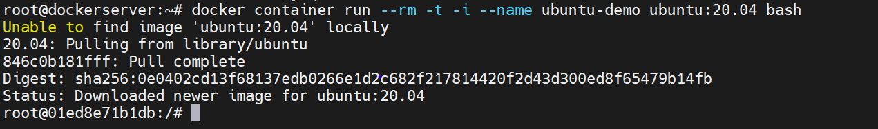

Try out some of the commands after login into the container like date and ls -l. While date command will print the date and time besides ls -l command gives the long list of all the directories and files present in the host machine.

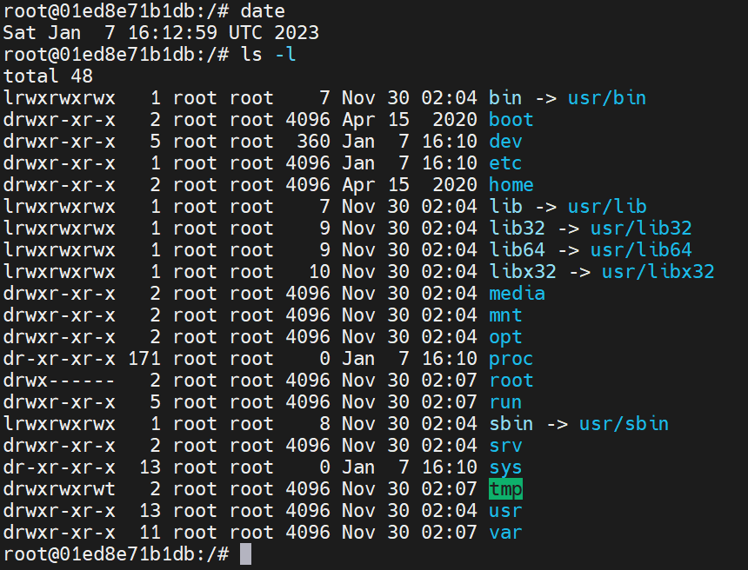

apt update is used for updating all the repositories and packages.

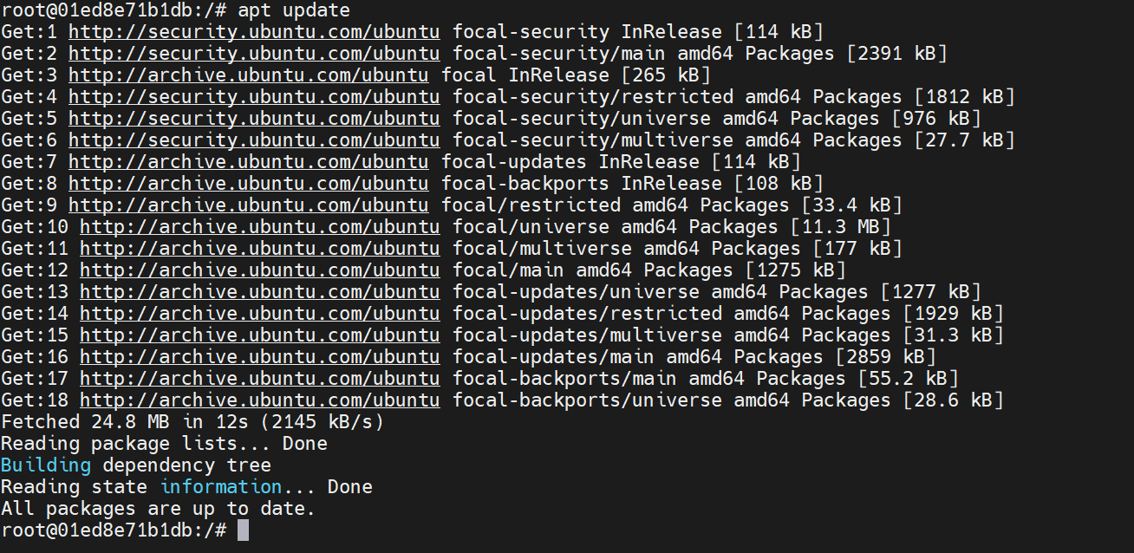

exit command will exit from the container.



docker container ps command will list the running processes.



docker container ps -a command will list all the running processes.



**Scenario-2**

In this case, Container will only get created and will be in the running state. We need to login manually by using docker exec command thus the container will be in running state after exiting.

This container will not be deleted automatically after exiting.

docker container run will create the container using the specified image and -d is for detach mode, –name is for name of the container.



docker container ps command will list the running processes.



docker container exec command is used to login to the container and -t is for terminal, -i is for interactive, provide container name and bash shell for login.



Run some of the commands in the container like pwd for showing present working directory, cd for changing directory and date command is to show date. Run apt update to check internet connectivity as apt update is used for updating all the repositories and packages.

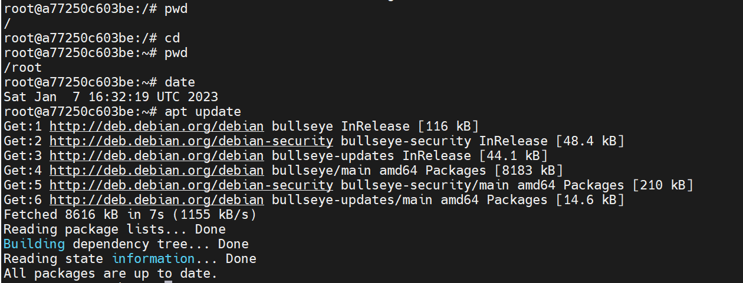

exit command will exit from the container.



docker container ps command will list the running processes. Here the container is still running after exiting from the container.



**Scenario-3**

In this case, the existing container will be logged in using docker container exec command and if given any command(ex: cat /etc/hosts) succeeding docker container exec will be executed simultaneously after which output of the latter command will be printed.

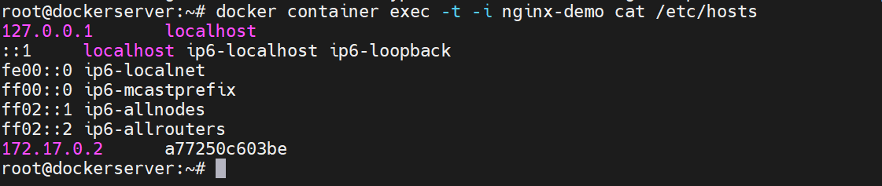

**Scenario-4 (Difference between create and run commands)**

***CREATE:***

docker container create –name container_name image_name command is used to create the container. Container is just created yet not in a running state.



docker container ps command will list the running processes. The above created container will not be listed with docker container ps command as it will list only the running container.



However this container is listed with docker ps -a command as it lists all the containers.



To run this container, first we need to start the container using docker container start command.



Now it is listed in the docker container ps command as it is running.



docker container stop container_name command will stop the running container.



docker container rm container_name command will remove the stopped container.



Finally the container is deleted, we can check it through the docker container ps -a command.



***RUN:***

docker container run -d –name container_name command will create and run the container. Both will be done through a single command. Here -d is for detach mode.



In docker container ps command the above created container is listed as it is in running state.

